Exp.No-6

6. Perform basic video processing operations on the captured video
• Read captured video in python and display the video, in slow motion and in fast motion.

Aim:
To display a video in slow motion and fast motion using OpenCV.

Procedure:
- Start the program.
- Import the OpenCV library.
- Open the video file.
- Read each video frame.
- Display the video frame.
- Adjust the delay using waitKey () to control the playback speed.
- Press Q to stop the video.
- Release the video and close all windows.
- Stop the program.
Program:
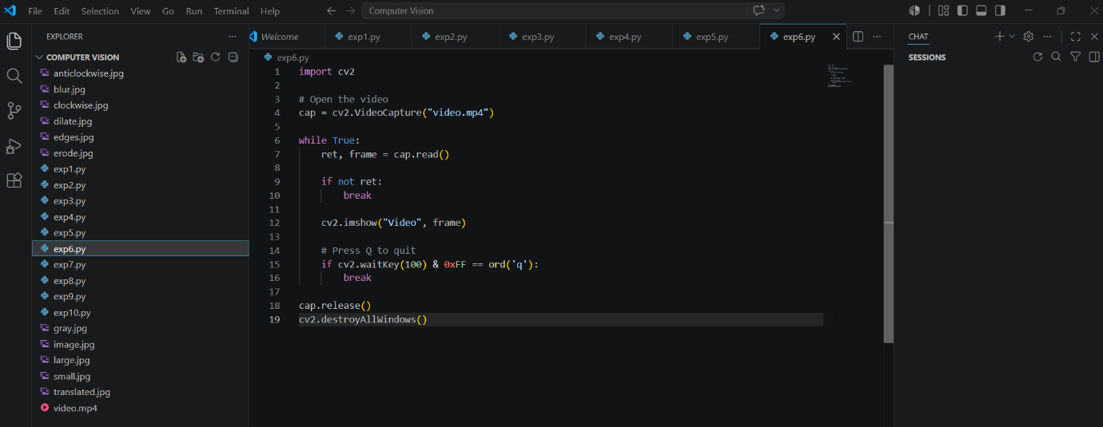

Output:
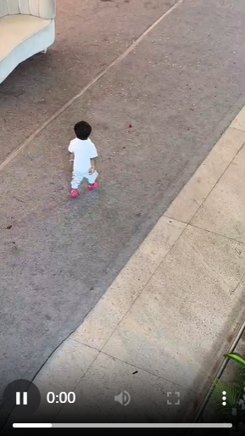
Result
The video was successfully played in slow motion and fast motion.

